**AMAZON ELASTIC FILE SYSTEM (EFS)**

Amazon EFS is a fully managed, scalable file storage service designed to provide shared access to files across multiple Amazon EC2 instances. It is particularly useful for applications and workloads that require shared file storage in a cloud environment.

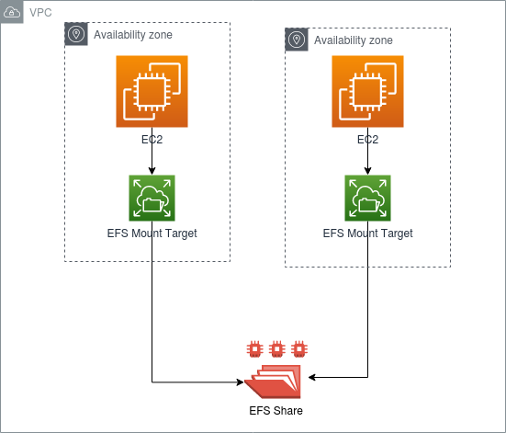

* **Create EFS and attach EFS to 3 different instances in 3 different availability zones**
* Open AWS concole and Create security group for the EFS purpose.
* Name the SG as EFS-SG and type allow at description and add imbound rules to the security group as SSH and ALL TRAFFIC in rules.

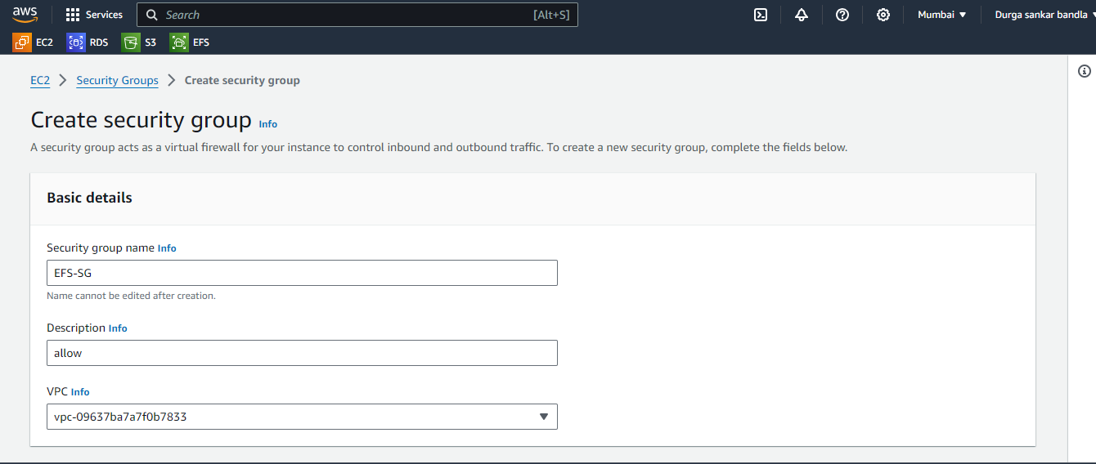

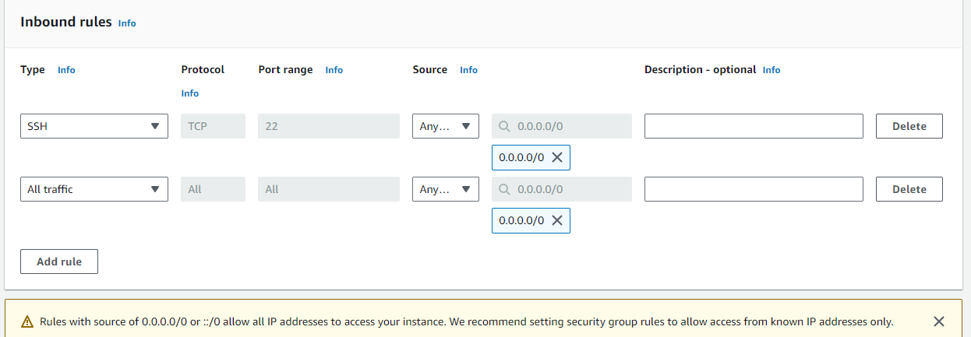

* After the creation of security group.
* Create EFS with the name of EFS with default vpc and then click on customize.
* And then remove the default security groups and add the security group created by us.
* And then click next and then click create file system.
* Edit network settings and add security group to availability zones.

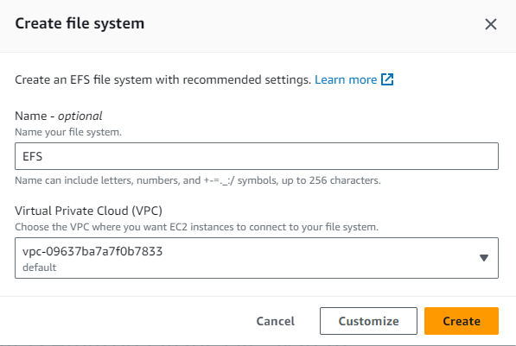

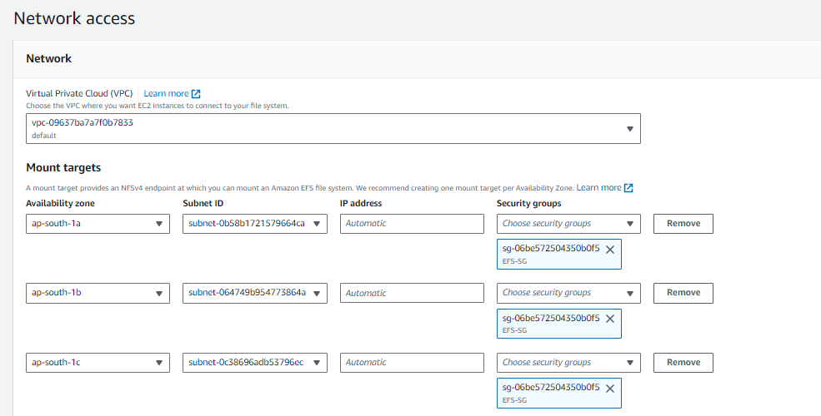

* Now Create 3 instances in 3 different availability zones names as EFS-EC1, EFS-EC2, EFS-EC3 and availability zones as vice versa ap-south-1a, ap-south-1b, ap-south-1c.

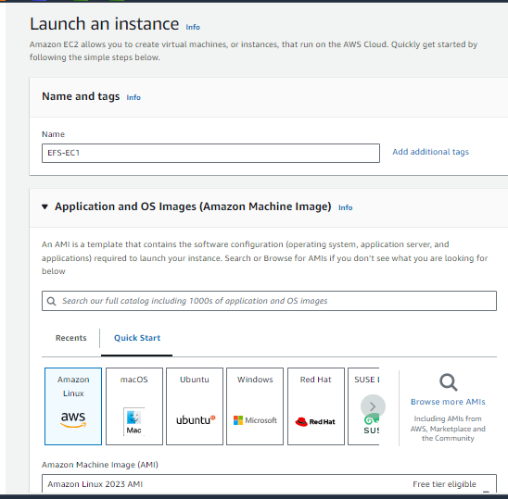

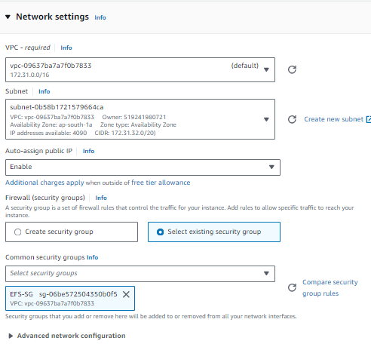

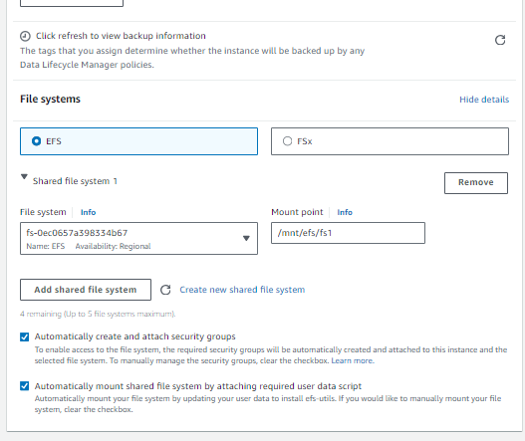

* While creating instances edit network settings choose vpc default and choose availability zones each one different for 3 instances.
* And then add existance security group.
* And then edit file systems.
* And then click on add file system wait for until it enables.
* And then click on add existance file system and then click on create instances by the same process create another two instances also.
* After creation connect to the three instances and then logon to root user with sudo -I command.
* And then go to the path where the EFS mounted cd /mnt/efs/fs1.
* And then create an file1 in EFS-EC1 and then connect to the EFS-EC2 and then check the path for the file we created in EFS-EC1
* Same as the process check the three instances for file systems.

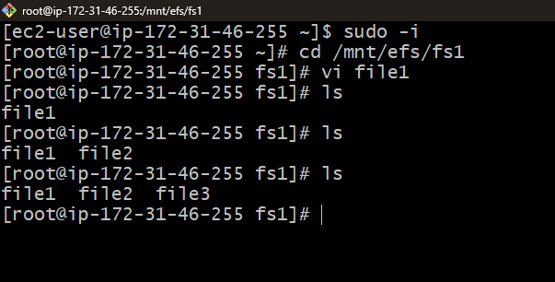

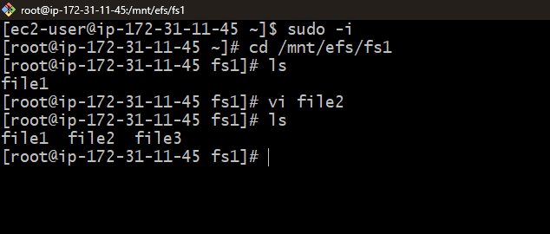

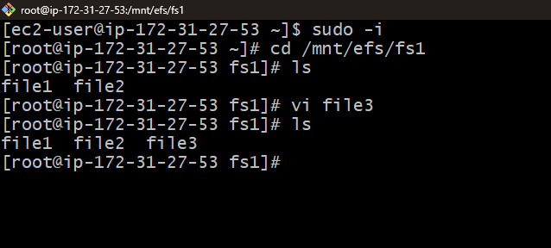

**B.Durgasankar**

[**durgasankarbandla99@gmail.com**](mailto:durgasankarbandla99@gmail.com)